Download Guide

To download the software, visit the Cashflow Manager Downloads Centre:
https://www.cashflow-manager.com.au/downloads/

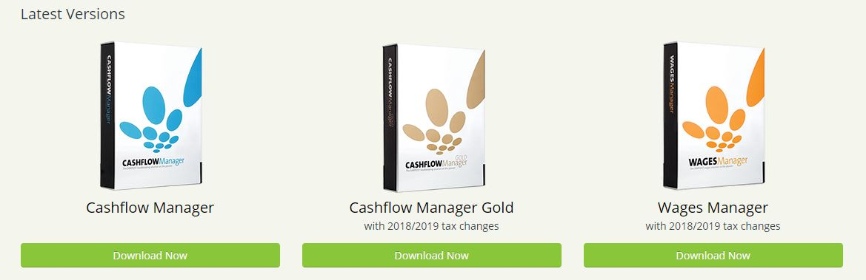
From here you can select the [Download Now] for your selected product:

Depending on the internet browser, you will receive a message asking you to ‘Run’ or ‘Save’ the CFMAUS.exe file. Or the file will start to download automatically.
Please Note: selecting ‘Run’, will run the download. Selecting ‘Save’ will save the download file to your desired location i.e.. Downloads.
Once the .exe file has completed downloading, you may or may not receive a generic Windows Security Message. This is a message created when downloading any type of software. The Cashflow Manager download is safe.

You will then be taken to a Cashflow Manager Setup Wizard. Click on [Next] to continue.
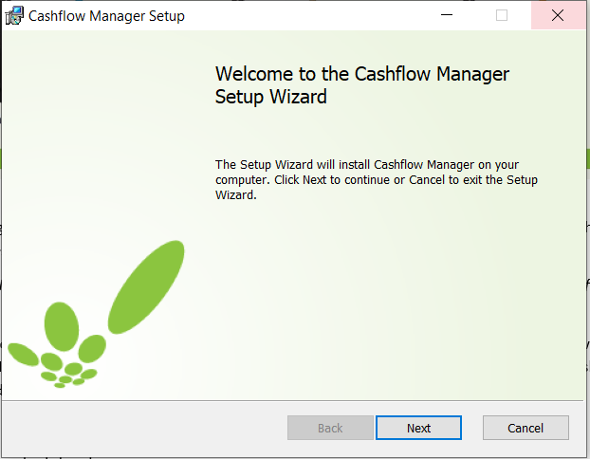

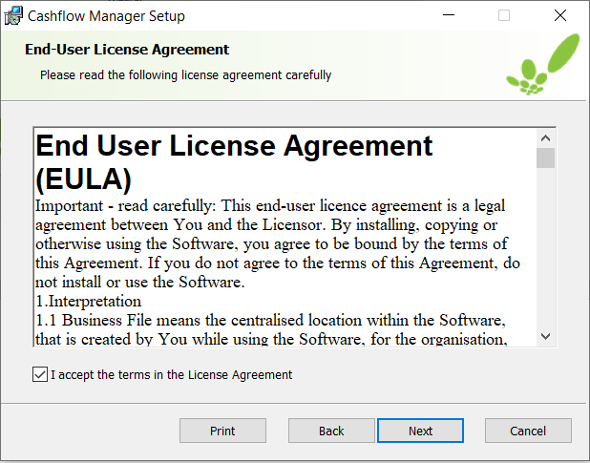
The next screen displays the End User License Agreement. Once you have read the agreement, tick the [I accept the terms in the License Agreement] and select [Next].

The next screen is installing the software to the default location. If you want to change where the software installs, click on the [Change] option and save it to your desired location. Then select [Next
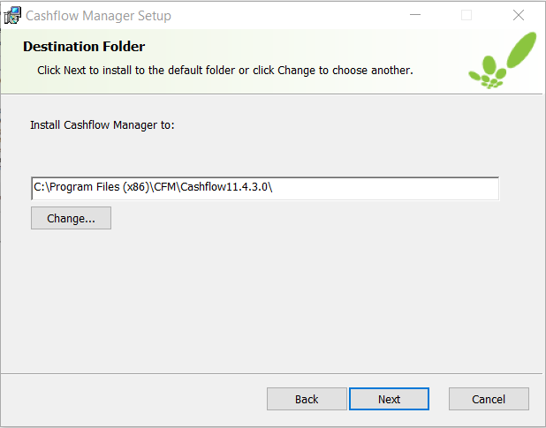

To complete the installing, click the [Install] button.
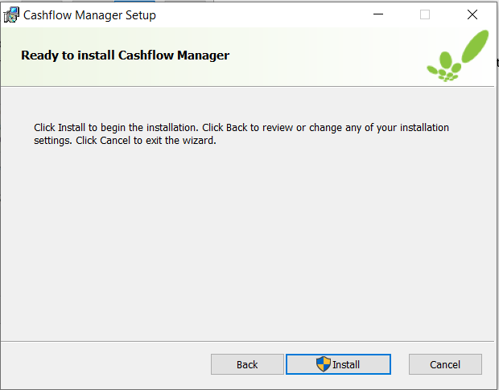

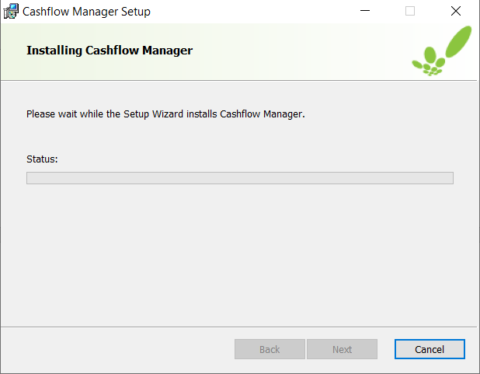
A Windows Installer message will then appear, asking if you want to install/make changes to this device. Select [Yes].

Your Cashflow installing will then be completed. Click on [Fishish] to exit the Setup wizard.

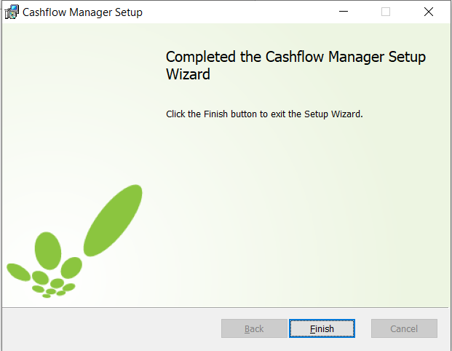

This will put a new Cashflow Manager icon on your desktop screen. When you click on the icon, the program will open.
To unlock your program, select the [Unlock] button.
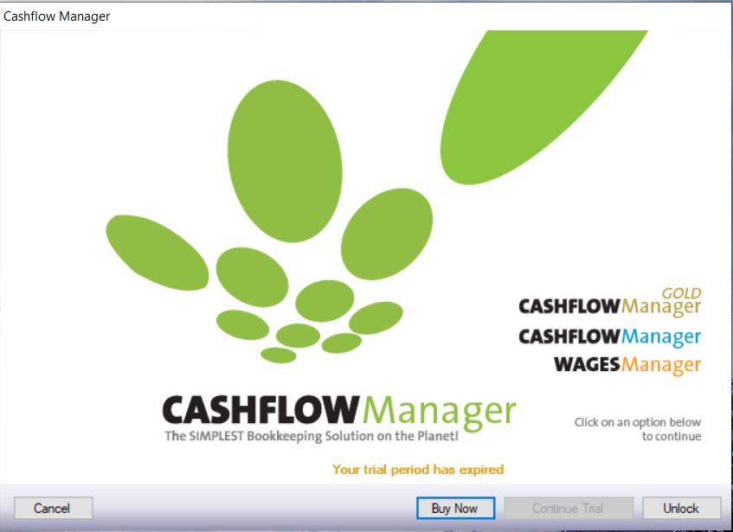

The next screen will provide the License Agreement. That can be viewed by clicking the [License Agreement]. Please select [Next] to continue.
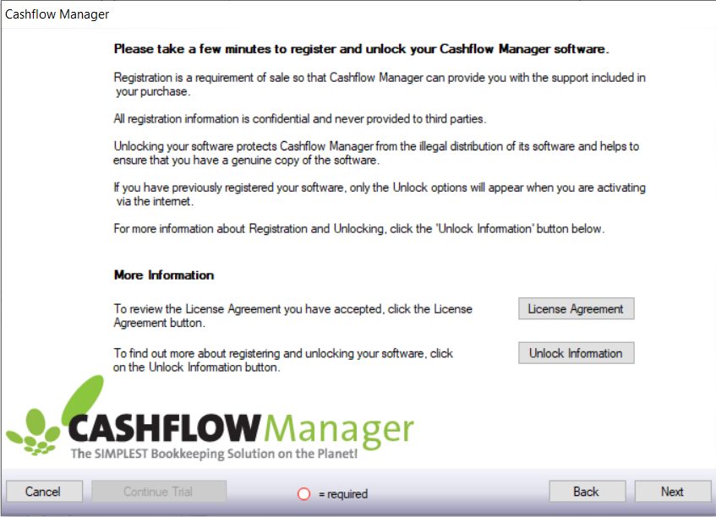

You can then enter in your Member ID and License Code in the fields provided.
Please Note: Letters will be capitalised automatically. There are no letter O’s in the License Code, they are number 0.

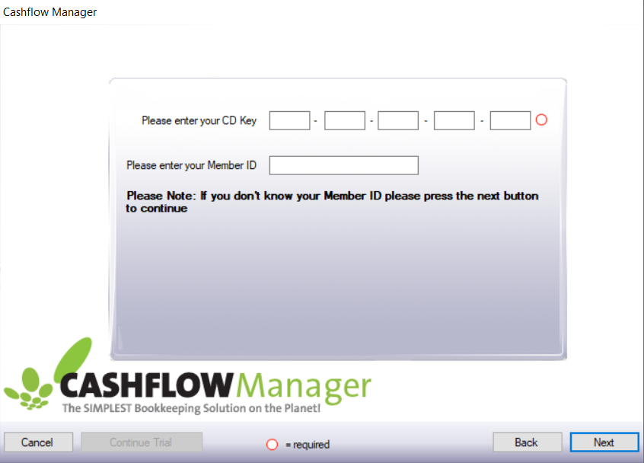

Once the fields are entered correctly, click on [Next]. You will then get a ‘Thank you for unlocking’ message.
This will then take you to the Welcome screen. From here you can either Create New Business, Open Existing Business or Open Sample Business.
To Import data from a previous version, select [Create New Business] and click [Next].
To Restore your backup file, refer to page 8.
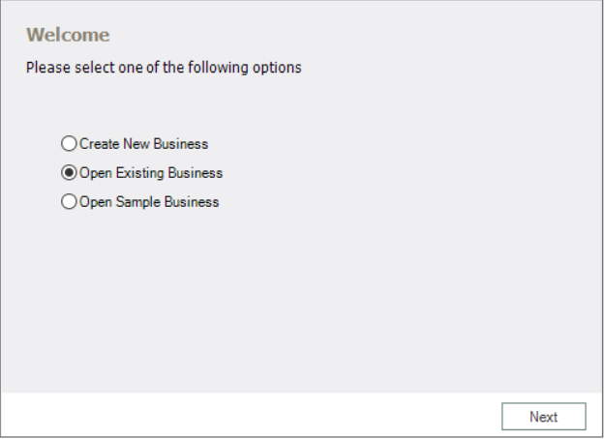

Select [Yes] and click [Next].
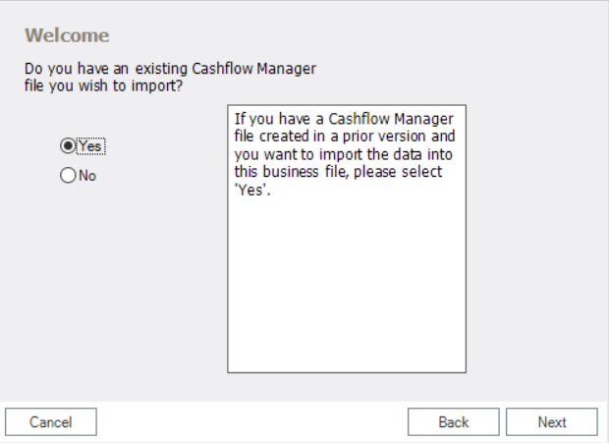

In the field provided, please enter your business name and click [Next].
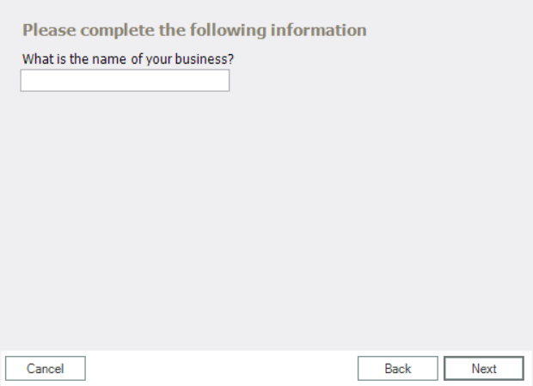
Please Note: This name doesn’t have to be what your file was originally called. The name you enter here will be recorded as your new file name.

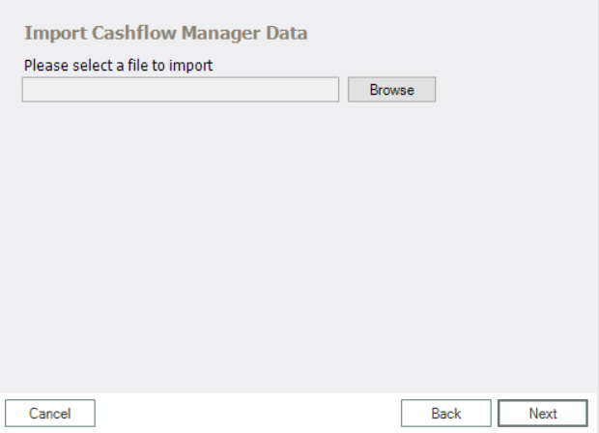
You can then select [Browse] and open your previous file.

When you click on [Browse]. Then your windows file explorer will open.

Depending on which version you were previously using, the files will be in different locations:
Version 7- C/ProgramFilesx86/CFM/Cashflow7/Data
Version 8- C/Users/Username/AppData/Roaming/CFM/Cashflow8/Data
Version 9 - C/Users/Username/Appdata/Roaming/CFM/Cashflow9/Data
Version 10 - C/Users/Username/Appdata/Roaming/CFM/Cashflow10/Data

Once you have selected your most recent data file. Click [Open]. This will bring you back to the Import Cashflow Manager Data screen. Click on [Next].
This will bring the windows file explorer window up again to the default save location. Click on [Save] in the bottom right. Your data will then load into the program.

To Restore your backup file, on the Welcome screen select the word [File] in the top left.
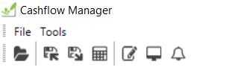
Then select [Restore]. This will bring up the Data Restore page. Click on [Browse] and navigate to where you have the backup file saved. Open the file and click on [Restore] in the bottom left.
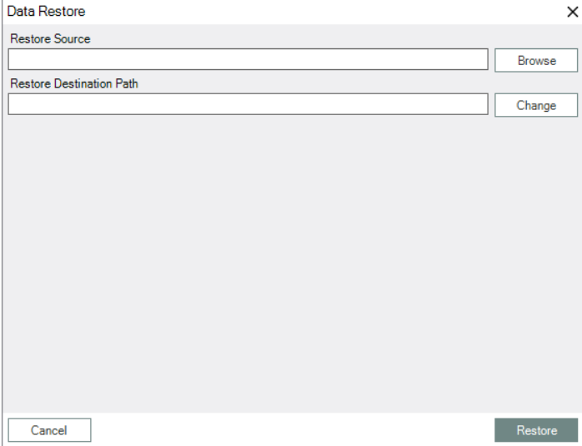

A message saying ‘Restore Complete’ will appear. Select [Ok] and the data will be restored into the program.

